**PROJECT FOR SQL MODULE**

**Gym Membership and Attendance System**

Institute Name**:-** Itvedant Education Pvt .Ltd

Name:- Adarsh Shetty

Email Address:- adarshshetty446@gmail.com

**Project Aims:**



**Centralized Member Management:**

* **Objective:** To create a system that can store and manage detailed information about gym members, including their personal details, membership types, and joining dates.
* **Impact:** This allows the gym management to have quick access to member data, improving customer service and enabling personalized interactions with members.

**Membership Type Tracking:**

* **Objective:** To implement a table that stores various membership types, along with their durations and prices.
* **Impact:** This feature allows the gym to offer a variety of membership plans to suit different customer needs. The system can be used to analyze which membership types are most popular, helping to optimize pricing strategies and membership offerings.

**Attendance Monitoring:**

* **Objective:** To track the attendance of gym members, recording the time they check in and out of the gym.
* **Impact:** This enables the gym to monitor member engagement and usage patterns, which can be critical for operational decisions like staffing, facility maintenance, and member retention efforts.

**Trainer Specialization and Assignment:**

* **Objective:** To maintain a database of trainers and their specializations, allowing the gym to match members with trainers who suit their fitness goals.
* **Impact:** This enhances the gym’s ability to provide tailored training programs, improving member satisfaction and potentially increasing membership renewals.

**Data Analysis and Reporting:**

* **Objective:** To create a system capable of generating detailed reports and insights, such as membership trends, attendance rates, and trainer utilization.
* **Impact:** These insights can be used to make informed decisions about marketing, staffing, and program development. For example, identifying peak attendance times can help in better scheduling trainers and optimizing gym usage.

**Improved Operational Efficiency:**

* **Objective:** To reduce the manual workload associated with managing member data, attendance tracking, and trainer assignments.
* **Impact:** By automating these processes, the gym can operate more efficiently, reducing errors and freeing up staff to focus on other important tasks, such as customer engagement and program development.

**Scalability and Future Expansion:**

* **Objective:** To design the system in a way that allows for easy expansion, whether in terms of adding new membership types, integrating additional facilities, or scaling up to manage a larger member base.
* **Impact:** This ensures that the system remains useful as the gym grows, providing a sustainable solution that supports long-term business goals.

**Security and Data Integrity:**

* **Objective:** To implement appropriate measures to ensure that the data within the system is secure and accurate.
* **Impact:** This is crucial for maintaining the trust of gym members and complying with any relevant data protection regulations. Secure data handling practices will help prevent unauthorized access and ensure that the information is always accurate and up-to-date.

The Gym Membership and Attendance System project aims to provide a comprehensive solution that not only meets the immediate needs of managing gym operations but also offers the flexibility and scalability to adapt to future requirements. By centralizing and automating key processes, the system will enhance the overall efficiency of the gym, improve member experience, and provide valuable insights to drive business growth.

**Project Objective:**

The objective of the Gym Membership and Attendance System project is to develop an integrated database management system that efficiently handles all aspects of gym operations related to membership, attendance, and trainer management.

Below is a detailed breakdown of the specific objectives:

**1. Comprehensive Member Data Management**

* **Objective:** Develop a system to maintain a detailed record of each gym member, including personal information, membership status, and joining dates.
* **Detail:** The system should allow the gym staff to easily add, update, and retrieve member information. This will ensure that member data is accurate and up-to-date, facilitating efficient customer service and targeted communication, such as notifications for membership renewals or special offers.

**2. Efficient Membership Type and Pricing Management**

* **Objective:** Implement a structured approach to managing different membership plans, including their duration, price, and associated benefits.
* **Detail:** The system will support various membership types (e.g., monthly, quarterly, annual) with customizable pricing and features. This flexibility allows the gym to cater to diverse customer needs and respond to market demands by adjusting membership offerings. It will also enable staff to quickly generate reports on membership sales and popularity, aiding in business strategy development.

**3. Automated Attendance Tracking**

* **Objective:** Enable precise and automated tracking of member attendance, including check-in and check-out times.
* **Detail:** The system should automatically record when members enter and leave the gym, either through manual input by staff or via integration with access control systems (e.g., swipe cards or biometric systems). This data will provide insights into member usage patterns, helping the gym to optimize operational hours, manage crowding, and enhance member experience by ensuring facilities are available when needed.

**4. Trainer Specialization and Assignment Management**

* **Objective:** Maintain a database of trainers, detailing their specializations and availability, to facilitate member-trainer matching.
* **Detail:** The system should allow gym staff to assign trainers to members based on their specific fitness goals and trainers' expertise. This functionality ensures that members receive personalized training, improving satisfaction and outcomes. It also allows management to monitor trainer workloads and effectiveness, ensuring that resources are allocated efficiently.

**5. Data-Driven Insights and Reporting**

* **Objective:** Provide tools for generating detailed reports on key metrics such as membership trends, attendance rates, and trainer utilization.
* **Detail:** The system will include reporting features that allow gym management to analyze data and generate insights for decision-making. For instance, reports can highlight peak usage times, popular membership plans, or high-performing trainers. This data-driven approach will support strategic planning, marketing, and resource allocation, ultimately driving business growth.

**6. Scalability and Flexibility**

* **Objective:** Design the system to accommodate future growth, including the addition of new membership plans, expansion of facilities, or scaling up to handle a larger member base.
* **Detail:** The system should be modular and scalable, allowing for easy updates and expansion. As the gym grows, the system can be adapted to manage additional members, new types of memberships, or additional locations without requiring a complete overhaul. This flexibility ensures that the system remains relevant and useful as the gym’s needs evolve.

**7. Enhanced Member Experience**

* **Objective:** Improve overall member satisfaction by providing a seamless and personalized experience through efficient data management and communication.
* **Detail:** By centralizing member data and streamlining operations, the system will enable staff to offer more personalized service, such as tailored workout programs or timely reminders for upcoming classes or renewals. Enhanced communication and better resource management will contribute to a more satisfying gym experience, encouraging member retention and loyalty.

**8. Operational Efficiency and Resource Optimization**

* **Objective:** Streamline gym operations by reducing manual workload, minimizing errors, and optimizing the use of resources such as trainers and equipment.
* **Detail:** The system should automate routine tasks such as membership renewals, attendance logging, and trainer assignments. This automation will reduce the risk of errors, free up staff time for more critical tasks, and ensure that resources are used effectively. For example, understanding peak attendance times can help in scheduling more trainers during busy periods and adjusting equipment maintenance schedules.

**9. Security and Compliance**

* **Objective:** Ensure that the system adheres to data protection regulations and implements robust security measures to protect member data.
* **Detail:** The system must incorporate secure data storage and access controls to protect sensitive information such as personal member details and financial transactions. Compliance with data protection laws (such as GDPR or equivalent) is crucial to maintaining member trust and avoiding legal issues. Regular audits and updates will ensure that the system remains secure against evolving threats.

**10. Support for Marketing and Member Retention Strategies**

* **Objective:** Provide tools that assist in marketing efforts and improving member retention.
* **Detail:** The system should allow the gym to track member engagement and identify trends that can inform marketing campaigns. For instance, identifying members who attend infrequently could trigger targeted offers or communication aimed at re-engaging them. Additionally, the system can support loyalty programs or special promotions that encourage long-term membership

The Gym Membership and Attendance System aims to be a comprehensive, efficient, and scalable solution that not only meets the immediate needs of gym management but also supports long-term growth and member satisfaction.

**In this ER diagram:**

* **Entities** are represented as rectangles.
* **Attributes** are listed inside the rectangles or connected by ovals.
* **Relationships** are represented by diamonds or lines connecting the entities.
* **Primary Keys** are underlined.
* **Foreign Keys** are indicated by connecting lines between entities.

**Table description:**

**1. MembershipTypes**

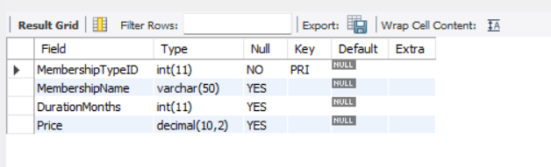

**2. Members**

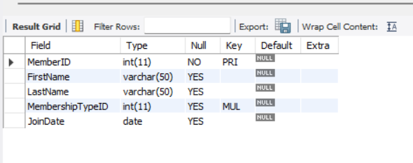

|  |  |  |  |  |
| --- | --- | --- | --- | --- |
| **3. Trainers** |  |  |  |  |

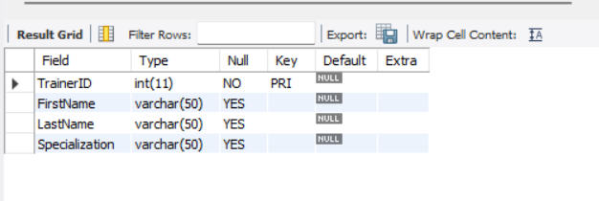

**4. AttendanceLogs**

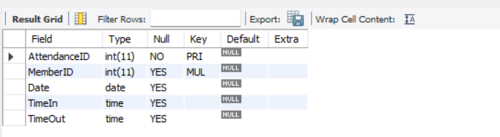

**Commands:**

**Create Database:**

create database project;

use project;

**Create and Insert Table:**

1. **MembershipTypes**

CREATE TABLE MembershipTypes (

MembershipTypeID INT PRIMARY KEY,

MembershipName VARCHAR(50),

DurationMonths INT,

Price DECIMAL(10, 2)

);

INSERT INTO MembershipTypes (MembershipTypeID, MembershipName, DurationMonths, Price) VALUES

(1, 'Basic', 1, 30.00),

(2, 'Standard', 3, 75.00),

(3, 'Premium', 6, 150.00),

(4, 'Annual', 12, 280.00),

(5, 'Student', 6, 100.00),

(6, 'Family', 12, 500.00),

(7, 'Corporate', 12, 450.00),

(8, 'Senior', 6, 90.00),

(9, 'Monthly Pass', 1, 35.00),

(10, 'Trial', 1, 20.00),

(11, 'VIP', 12, 600.00),

(12, 'Group', 3, 200.00),

(13, 'Weekend', 1, 25.00),

(14, 'Holistic', 6, 120.00),

(15, 'All Access', 12, 550.00),

(16, 'Weekend VIP', 3, 150.00),

(17, 'Youth', 6, 80.00),

(18, 'Athlete', 6, 110.00),

(19, 'Wellness', 12, 320.00),

(20, 'Fitness', 1, 40.00),

(21, 'Basic Plus', 3, 85.00),

(22, 'Elite', 12, 700.00),

(23, 'Seasonal', 6, 130.00),

(24, 'Fit Family', 12, 480.00),

(25, 'Gym Only', 3, 60.00),

(26, 'Gym & Pool', 6, 140.00),

(27, 'Pool Only', 1, 25.00),

(28, 'Personal Trainer', 1, 50.00),

(29, 'Gold', 12, 400.00),

(30, 'Silver', 6, 100.00);

1. **Members**

CREATE TABLE Members (

MemberID INT PRIMARY KEY,

FirstName VARCHAR(50),

LastName VARCHAR(50),

MembershipTypeID INT,

JoinDate DATE,

FOREIGN KEY (MembershipTypeID) REFERENCES MembershipTypes(MembershipTypeID)

);

INSERT INTO Members (MemberID, FirstName, LastName, MembershipTypeID, JoinDate) VALUES

(1, 'John', 'Doe', 1, '2024-01-01'),

(2, 'Jane', 'Smith', 2, '2024-01-05'),

(3, 'Alice', 'Johnson', 3, '2024-02-01'),

(4, 'Bob', 'Williams', 4, '2024-02-15'),

(5, 'Charlie', 'Brown', 5, '2024-03-01'),

(6, 'David', 'Jones', 6, '2024-03-10'),

(7, 'Emma', 'Garcia', 7, '2024-04-01'),

(8, 'Fiona', 'Martinez', 8, '2024-04-20'),

(9, 'George', 'Hernandez', 9, '2024-05-01'),

(10, 'Hannah', 'Young', 10, '2024-05-15'),

(11, 'Isaac', 'Moore', 11, '2024-06-01'),

(12, 'Jack', 'Taylor', 12, '2024-06-10'),

(13, 'Kylie', 'Anderson', 13, '2024-07-01'),

(14, 'Liam', 'Thomas', 14, '2024-07-15'),

(15, 'Mia', 'Jackson', 15, '2024-08-01'),

(16, 'Noah', 'White', 16, '2024-08-10'),

(17, 'Olivia', 'Harris', 17, '2024-09-01'),

(18, 'Paul', 'Martin', 18, '2024-09-15'),

(19, 'Quinn', 'Thompson', 19, '2024-10-01'),

(20, 'Rachel', 'Garcia', 20, '2024-10-10'),

(21, 'Sam', 'Roberts', 21, '2024-11-01'),

(22, 'Tina', 'Clark', 22, '2024-11-15'),

(23, 'Ursula', 'Lewis', 23, '2024-12-01'),

(24, 'Victor', 'Walker', 24, '2024-12-10'),

(25, 'Wendy', 'Hall', 25, '2024-01-20'),

(26, 'Xander', 'Allen', 26, '2024-02-01'),

(27, 'Yara', 'King', 27, '2024-03-05'),

(28, 'Zach', 'Scott', 28, '2024-04-01'),

(29, 'Anna', 'Nelson', 29, '2024-05-10'),

(30, 'Brian', 'Adams', 30, '2024-06-01');

1. **Trainers**

CREATE TABLE Trainers (

TrainerID INT PRIMARY KEY,

FirstName VARCHAR(50),

LastName VARCHAR(50),

Specialization VARCHAR(50)

);

INSERT INTO Trainers (TrainerID, FirstName, LastName, Specialization) VALUES

(1, 'Alice', 'Wright', 'Cardio'),

(2, 'Bob', 'Kane', 'Strength Training'),

(3, 'Cathy', 'Owen', 'Yoga'),

(4, 'David', 'Parker', 'Pilates'),

(5, 'Ella', 'Morgan', 'HIIT'),

(6, 'Frank', 'Lee', 'CrossFit'),

(7, 'Grace', 'Morris', 'Functional Training'),

(8, 'Harry', 'Bell', 'Boxing'),

(9, 'Ivy', 'Young', 'Stretching'),

(10, 'James', 'Cole', 'Nutrition'),

(11, 'Kelly', 'Ward', 'Cardio'),

(12, 'Liam', 'Hughes', 'Strength Training'),

(13, 'Mia', 'Wood', 'Yoga'),

(14, 'Nathan', 'Watson', 'Pilates'),

(15, 'Olivia', 'Price', 'HIIT'),

(16, 'Paul', 'Butler', 'CrossFit'),

(17, 'Quinn', 'Ross', 'Functional Training'),

(18, 'Rachel', 'Peterson', 'Boxing'),

(19, 'Steve', 'Gray', 'Stretching'),

(20, 'Tina', 'Cooper', 'Nutrition'),

(21, 'Ulysses', 'Richardson', 'Cardio'),

(22, 'Vera', 'Cox', 'Strength Training'),

(23, 'Will', 'Jenkins', 'Yoga'),

(24, 'Xena', 'Curtis', 'Pilates'),

(25, 'Yosef', 'Rogers', 'HIIT'),

(26, 'Zara', 'Wood', 'CrossFit'),

(27, 'Anna', 'Murray', 'Functional Training'),

(28, 'Brian', 'Bailey', 'Boxing'),

(29, 'Chloe', 'Reed', 'Stretching'),

(30, 'Daniel', 'Gray', 'Nutrition');

1. **AttendanceLogs**

CREATE TABLE AttendanceLogs (

AttendanceID INT PRIMARY KEY,

MemberID INT,

Date DATE,

TimeIn TIME,

TimeOut TIME,

FOREIGN KEY (MemberID) REFERENCES Members(MemberID)

);

INSERT INTO AttendanceLogs (AttendanceID, MemberID, Date, TimeIn, TimeOut) VALUES

(1, 1, '2024-08-01', '08:00:00', '09:00:00'),

(2, 2, '2024-08-01', '09:00:00', '10:00:00'),

(3, 3, '2024-08-01', '10:00:00', '11:00:00'),

(4, 4, '2024-08-01', '11:00:00', '12:00:00'),

(5, 5, '2024-08-01', '12:00:00', '13:00:00'),

(6, 6, '2024-08-01', '13:00:00', '14:00:00'),

(7, 7, '2024-08-01', '14:00:00', '15:00:00'),

(8, 8, '2024-08-01', '15:00:00', '16:00:00'),

(9, 9, '2024-08-01', '16:00:00', '17:00:00'),

(10, 10, '2024-08-01', '17:00:00', '18:00:00'),

(11, 11, '2024-08-02', '08:00:00', '09:00:00'),

(12, 12, '2024-08-02', '09:00:00', '10:00:00'),

(13, 13, '2024-08-02', '10:00:00', '11:00:00'),

(14, 14, '2024-08-02', '11:00:00', '12:00:00'),

(15, 15, '2024-08-02', '12:00:00', '13:00:00'),

(16, 16, '2024-08-02', '13:00:00', '14:00:00'),

(17, 17, '2024-08-02', '14:00:00', '15:00:00'),

(18, 18, '2024-08-02', '15:00:00', '16:00:00'),

(19, 19, '2024-08-02', '16:00:00', '17:00:00'),

(20, 20, '2024-08-02', '17:00:00', '18:00:00'),

(21, 21, '2024-08-03', '08:00:00', '09:00:00'),

(22, 22, '2024-08-03', '09:00:00', '10:00:00'),

(23, 23, '2024-08-03', '10:00:00', '11:00:00'),

(24, 24, '2024-08-03', '11:00:00', '12:00:00'),

(25, 25, '2024-08-03', '12:00:00', '13:00:00'),

(26, 26, '2024-08-03', '13:00:00', '14:00:00'),

(27, 27, '2024-08-03', '14:00:00', '15:00:00'),

(28, 28, '2024-08-03', '15:00:00', '16:00:00'),

(29, 29, '2024-08-03', '16:00:00', '17:00:00'),

(30, 30, '2024-08-03', '17:00:00', '18:00:00');

**Show Tables :**

1. **select * from MembershipTypes;**

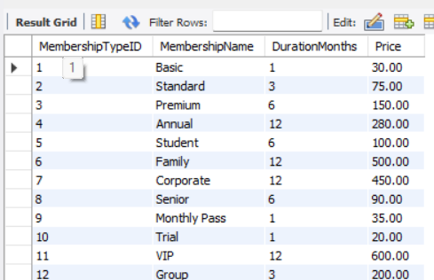

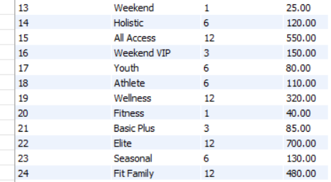

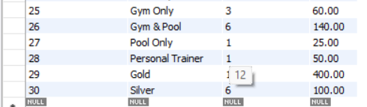

1. **select * from Members:**

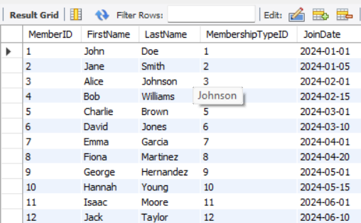 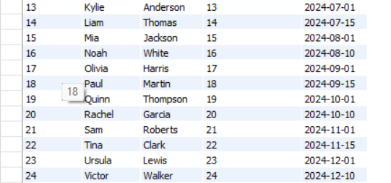 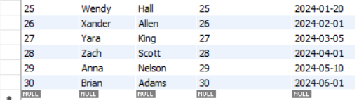

1. **select * from Trainers:**

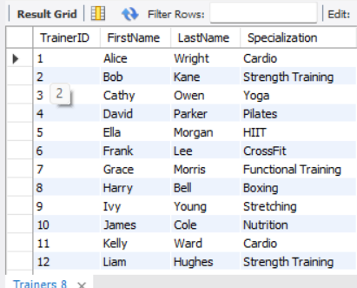

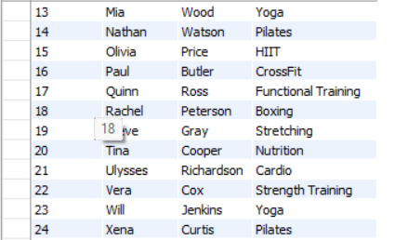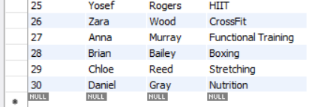

1. **select * from AttendanceLogs:**

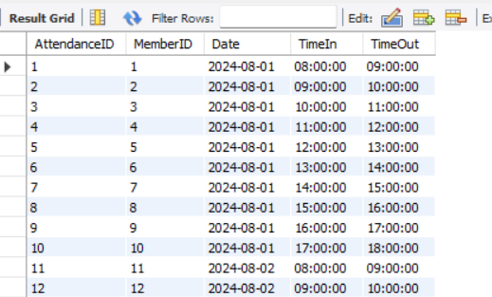

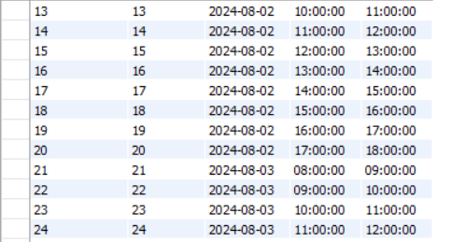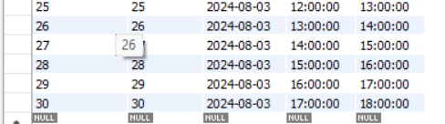

**Queries:**

1.

**List all members who joined in 2024:**

SELECT * FROM Members WHERE YEAR(JoinDate) = 2024;

1. **Find all members with a 'Premium' membership:**

SELECT * FROM Members WHERE MembershipTypeID = (SELECT MembershipTypeID FROM MembershipTypes WHERE MembershipName = 'Premium');

1. **Get the total number of members with 'Annual' membership:**

SELECT COUNT(*) FROM Members WHERE MembershipTypeID = (SELECT MembershipTypeID FROM MembershipTypes WHERE MembershipName = 'Annual');

1. **Retrieve all attendance logs for a specific member:**

SELECT * FROM AttendanceLogs

WHERE MemberID = 1;

1. **List all trainers who specialize in 'Cardio':**

6.

7.

SELECT * FROM Trainers

WHERE Specialization = 'Cardio';

**Get the average price of all membership types:**

SELECT AVG(Price) FROM MembershipTypes;

 **Find all members who joined in January 2024:**

SELECT * FROM Members WHERE MONTH(JoinDate) = 1 AND YEAR(JoinDate) = 2024



1. **Get the total number of attendees on '2024-08-01':**

SELECT COUNT(*) FROM AttendanceLogs WHERE Date = '2024-08-01';

1. **List all membership types that cost more than $100:**

SELECT * FROM MembershipTypes WHERE Price > 100.00;

1. **Retrieve all members who have attended the gym more than 5 times:**

SELECT MemberID FROM AttendanceLogs GROUP BY MemberID

HAVING COUNT(*) > 5;

1. **Find all members with 'Student' membership:**

SELECT * FROM Members WHERE MembershipTypeID = (SELECT MembershipTypeID FROM MembershipTypes WHERE MembershipName = 'Student');

1. **List all attendance logs between '2024-08-01' and '2024-08-02':**

SELECT * FROM AttendanceLogs WHERE Date BETWEEN '2024-08-01' AND '2024-08-02';

1. **Get the details of members with a 'Basic' membership:**

SELECT * FROM Members WHERE MembershipTypeID = (SELECT MembershipTypeID FROM MembershipTypes WHERE MembershipName = 'Basic');

1. **List all trainers specializing in 'Boxing' or 'Yoga':**

SELECT * FROM Trainers WHERE Specialization IN ('Boxing', 'Yoga');

1. **Find the total number of unique membership types:**

SELECT COUNT(DISTINCT MembershipName) FROM MembershipTypes;

**Subqueries Queries:**

1. **Find all members who have the 'VIP' membership:**

SELECT FirstName, LastName

FROM Members

WHERE MembershipTypeID = (SELECT MembershipTypeID FROM MembershipTypes WHERE MembershipName = 'VIP');

1. **List all members who joined after the average join date:**

SELECT FirstName, LastName

FROM Members

WHERE JoinDate > (SELECT AVG(JoinDate) FROM Members);

1. **Get all trainers specializing in 'Yoga' or 'Pilates' using a subquery:**

SELECT FirstName, LastName

FROM Trainers

WHERE Specialization IN (SELECT Specialization FROM Trainers WHERE Specialization IN ('Yoga', 'Pilates'));

1. **Find the highest-priced membership and list its details:**

SELECT MembershipName, DurationMonths, Price

FROM MembershipTypes

WHERE Price = (SELECT MAX(Price) FROM MembershipTypes);

1. **Get members who attended the gym at least 3 times in a single day:**

SELECT FirstName, LastName

FROM Members

WHERE MemberID IN (

SELECT MemberID

FROM AttendanceLogs

GROUP BY MemberID, Date

HAVING COUNT(AttendanceID) >= 3

);

**Joins Queries:**

1. **List all members with their membership type details:**

SELECT Members.FirstName, Members.LastName, MembershipTypes.MembershipName, MembershipTypes.Price

FROM Members

JOIN MembershipTypes ON Members.MembershipTypeID = MembershipTypes.MembershipTypeID;

1. **Get attendance logs with member names:**

SELECT AttendanceLogs.Date, AttendanceLogs.TimeIn, AttendanceLogs.TimeOut, Members.FirstName, Members.LastName

FROM AttendanceLogs

JOIN Members ON AttendanceLogs.MemberID = Members.MemberID;

1. **Find all trainers who have the same specialization as 'Alice Wright':**

SELECT T1.FirstName, T1.LastName, T1.Specialization

FROM Trainers T1

JOIN Trainers T2 ON T1.Specialization = T2.Specialization

WHERE T2.FirstName = 'Alice' AND T2.LastName = 'Wright';

1. **List all members and their corresponding trainers:**

SELECT Members.FirstName AS MemberFirstName, Members.LastName AS MemberLastName, Trainers.FirstName AS TrainerFirstName, Trainers.LastName AS TrainerLastName

FROM Members

JOIN Trainers ON Members.MemberID = Trainers.TrainerID;

1. **Get the total number of gym visits by each member:**

SELECT Members.FirstName, Members.LastName, COUNT(AttendanceLogs.AttendanceID) AS TotalVisits

FROM Members

JOIN AttendanceLogs ON Members.MemberID = AttendanceLogs.MemberID

GROUP BY Members.FirstName, Members.LastName;

**Conclusion**

The Gym Membership and Attendance System project provides a comprehensive and scalable solution tailored to the operational needs of a modern gym. By centralizing member management, membership types, attendance tracking, and trainer assignments within an integrated database system, the project enhances the efficiency of gym operations while significantly improving the member experience.